**CVLX Sheep & Lamb Sale- Selected Date**

**Report Date: 18/02/20252025**

Total Yarding: 32545 (-15917) | Sheep Yarding: 6103 (-10302) | Lamb Yarding: 26442 (-5615)

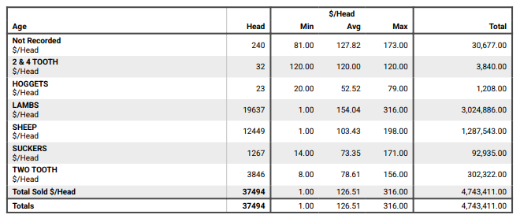Lamb numbers dropped to 26,442 yarded. Quality improved over the trade and export weight categories, the lighter weights became patchy ranging from plain to very good. All the usual buying group attended in a market that opened very strong over the lighter store and trade weight lambs and remained strong for the extra heavy export weights, however became erratic through the medium and heavy trade weights and in places sales were to $20/head cheaper for the start of the market. Light store and trade lambs sold from $6 to $10 dearer. The general run of medium and heavy trade ended $6 to $10 softer however there were isolated sales selling firm on last week’s levels for the really neat well finished lambs in short skins. Extra heavy export lambs were in limited supply and in high demand, presenting in excellent condition to sell to a top of $317 to be $7 to $14/head dearer. Lambs back to the paddock made from $40 to $150 and $141 to $172/head to feed on. Light trade lambs under 18kg to suit MK orders sold from $75 to 150/head, averaging 740c to 820c/kg cwt. Trade lambs 18 to 22kg sold from $144 to $180/head, 22 to 26kg sold $171 to $228/head, to average 760c to 810c/kg cwt. Heavy export lambs over 26kg made from $219 to $317/head, to average of 820c to 840c/kg cwt. Hoggets from $52 to $120 for the Merino’s and $56 to $181/head for the crossbreds. Mutton numbers declined to 6,103 penned on the back of last week’s softer sale. All the usual buying group were on the rail, but not all were active in a stronger market with some sales to $20/head dearer. Merino wethers made from $56 to $111 for the lighter weights and the heavier weights sold from $90 to $120, gaining $5 to $10/head. Light weight Merino ewes made from $48 to $93, and the heavier weights sold from $115 to $156, selling from $8 to $20/head stronger. Heavy crossbred mutton made from $87 to $141, to be $4 to $6 dearer and the lighter weights made from $60 to $99 selling $8 to $14 stronger. Market Reporter: Sheona Lamb